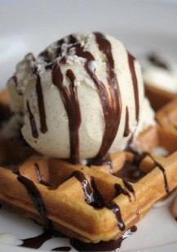
~Ice Creams~

Ice-cream Waffle

IC1 | ICE CREAM – SINGLE SCOOP | 雪糕 (1粒) | $2.20
IC2 | ICE CREAM – DOUBLE SCOOP | 雪糕 (2粒) | $3.80
IC3 | ICE-CREAM WAFFLE (SINGLE SCOOP) | 华夫格雪糕 (1粒) | $6.90
 | ICE-CREAM FLAVOURS | 雪糕口味
(ICA) | VANILLA | 香草
(ICB) | CHOCOLATE COOKIES CHIP | 巧克力饼芯片
(ICC) | STRAWBERRY CREAM | 草莓
(ICD) | MANGO | 芒果
(ICE) | COTTON CANDY BUBBLEGUM | 棉花泡泡糖
(ICI) | CARAMEL ALMOND NUTS | 焦糖杏仁
 | ADDITIONAL TOPPING ( 另加 )
A | CHOCOLATE RICE | 巧克力米 | $0.50
C | CHOCOLATE SYRUP | 巧克力浆 | $0.50
D | ADDITIONAL SINGLE SCOOP | 加雪糕 (1粒) | $1.50
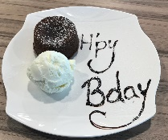
~Cakes
LA3 | SALTED CARAMEL MOLTEN LAVA CAKE WITH ICE-CREAM | 焦糖岩溶蛋糕 | $7.90
LA4 | DARK CHOCOLATE MOLTEN LAVA CAKE WITH ICE-CREAM | 巧克力岩溶蛋糕 | $7.90
LA5 | TIRAMISU MOLTEN LAVA CAKE WITH ICE-CREAM | 提拉米苏岩溶蛋糕 | $7.90
 | *(LA3 to LA5 Ice-Cream is Vanilla Flavoured Only)
CB1 | ICE WHITE COFFEE | 冰白咖啡 | $3.00
CB2 | ICED CAFÉ LATTE | 冰拿铁 | $5.50
CB3 | ICED CAFÉ VANILLA LATTE | 冰香草拿铁 | $5.90
CB4 | ICED CAFÉ HAZEL NUT LATTE | 冰榛子拿铁 | $5.90
CB7 | ICE LIPTON TEA | 冰立顿红茶 | $1.50
CB8 | ICE LIPTON TEA WITH MILK | 冰立顿红茶加奶 | $1.80
CB9 | ICE LEMON TEA | 冰柠檬茶 | $2.20
CB10 | ICE MILO | 冰美禄 | $2.20
CB11 | JUMBO MILO DINOSAUR | 冰恐龙美禄 | $3.50
CB12 | ICE BLENDED LIME JUICE | 冰沙酸柑汁 | $2.80
CB13 | ICE BLENDED LIME JUICE W/ SOUR PLUM | 冰沙酸梅酸柑汁 | $3.20
CB14 | SJORA MANGO | 冰芒果汁 | $3.00
CB15 | ICE HONEY LEMON | 冷蜜糖柠檬 | $2.50
CB16 | FRESH COCONUT JUICE | 椰子水 | $5.00
CB17 | COKE FLOAT (VANILLA) | 可乐加香草雪糕 | $3.80
CB18 | ROSE SYRUP W/ LIME | 玫瑰露加酸柑 | $2.00
CB19 | ROSE SYRUP | 玫瑰露 | $1.50
CB20 | ROSE BANDUNG | 万隆 | $2.00
CB21 | MINERAL WATER | 矿泉水 | $1.80
CB22 | RIBENNA (PACKET) | 利宾纳 | $2.20
CB23 | COKE | 可乐 | $1.80
CB24 | COKE ZERO | 无糖可乐 | $1.80
CB25 | SPRITE | 雪碧 | $1.80
CB26 | 100 PLUS | 100 PLUS | $1.80
CB27 | SOYA BEAN | 豆奶 | $1.80
CB28 | CHRYSANTHEMUM | 菊花 | $1.80
CB29 | HEAVEN & EARTH GREEN TEA | 绿茶 | $1.80
CB30 | COLD ICE WATER | 冷水 | $0.50
CB31 | AYATAKA GREEN TEA | 无糖绿茶 | $1.80
CB32 | OOLONG TEA | 乌龙茶 | $1.80
CB33 | ICE LIMAU CLEAR | 冰酸柑水 | $2.00
CB39/CB40 JUG / TOWER |  | 壶/塔 | $25.00 / $20.00
 | 1) ROSE SYRUP ( JUG / TOWER ) | 玫瑰露
 | 2) BANDUNG ( JUG / TOWER ) | 万隆
 | 3) ICE MILO ( JUG / TOWER ) | 冰美禄
 | 4) FRUIT PUNCH ( JUG / TOWER ) | 果汁喷趣饮料
 | 5) LIME ROSE ( Available in JUG Only ) | 酸柑玫瑰
 | 6) ICE LEMON TEA ( Available in JUG Only ) | 冰柠檬茶
~Cold Beverages~
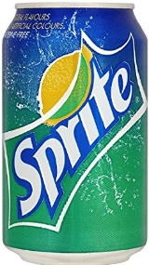

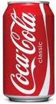

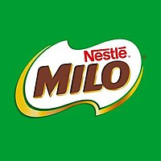
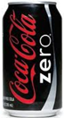
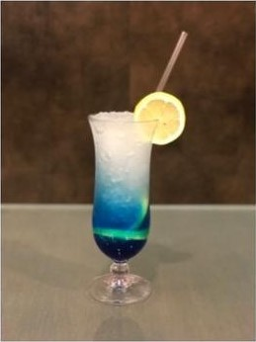
~Mocktails~
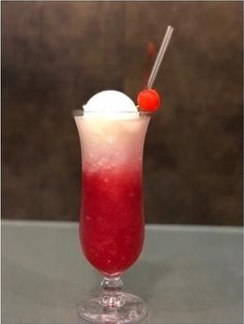
M1 | FOUNTAIN FLOAT | 喷泉浮子 | $7.90
M2 | BLUE OCEAN | 蓝色海洋 | $5.90
M3 | PEACH COOLER | 夏日蜜桃 | $5.90
M4 | VIRGIN MOJITO | 初念情人 | $5.90
M5 | GREEN FOREST | 绿色森林 | $5.90

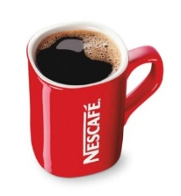
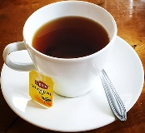
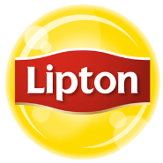
~Hot Beverages~
HB1 | NESCAFE BLACK COFFEE | 黑咖啡 | $1.40
HB2 | NESCAFE COFFEE WITH MILK | 咖啡加奶 | $1.80
HB3 | NESCAFE WHITE COFFEE | 白咖啡 | $2.50
HB4 | TEH TARIK | 拉奶茶 | $2.00
HB5 | AMERICANO | 美式咖啡 | $3.90
HB6 | ESPRESSO | 浓咖啡 | $3.50
HB7 | CAFÉ LATTE | 拿铁 | $4.50
HB7A | CAFÉ VANILLA LATTE | 香草拿铁 | $4.90
HB7B | CAFÉ HAZELNUT LATTE | 榛子拿铁 | $4.90
HB8 | CAPPUCCINO | 卡布奇诺咖啡 | $4.50
HB10 | LIPTON TEA | 立顿红茶 | $1.20
HB11 | LIPTON TEA WITH MILK | 立顿红茶加奶 | $1.50
HB12 | LIPTON TEA WITH LEMON | 柠檬红茶 | $1.50
HB12A | LIPTON TEA WITH LIME | 酸柑红茶 | $1.50
HB13 | EARL GREY TEA | 伯爵灰茶 | $3.50
HB14 | ENGLISH BREAKFAST TEA | 英式早餐茶 | $3.50
HB15 | CHAMOMILE | 黄春菊 | $3.50
HB16 | CHRYSANTHEMUM TEA | 菊花 | $1.20
HB17 | CHINESE TEA | 中国茶 | $1.20
HB18 | MILO | 美禄 | $1.80
HB19 | HONEY LEMON | 蜜糖柠檬 | $1.80
HB21 | VANILLA | 香草 | $4.00
HB22 | WARM WATER | 温水 | $0.50
HB23 | HOT WATER | 热水 | $0.50
HB24 | HOT LIME | 热酸柑水 | $1.20

